David O. McKay Library

Self-Guided Walking Tour

Fall Semester 2008

Welcome to the David O. McKay Library at BYU-Idaho. Our resources consist of a collection containing over 700,000 cataloged items, including excellent reference collection. This tour will introduce library services and technologies that are available for information retrieval. Becoming acquainted with these services will help you in your personal and educational interests.
While on this tour, please observe your surroundings and notice the location of important collections and services. These will be designated by grey and white signs. If you have questions or need clarification during the tour, please ask one of the librarians or library assistants. Enjoy your tour.

West Wing– First Floor

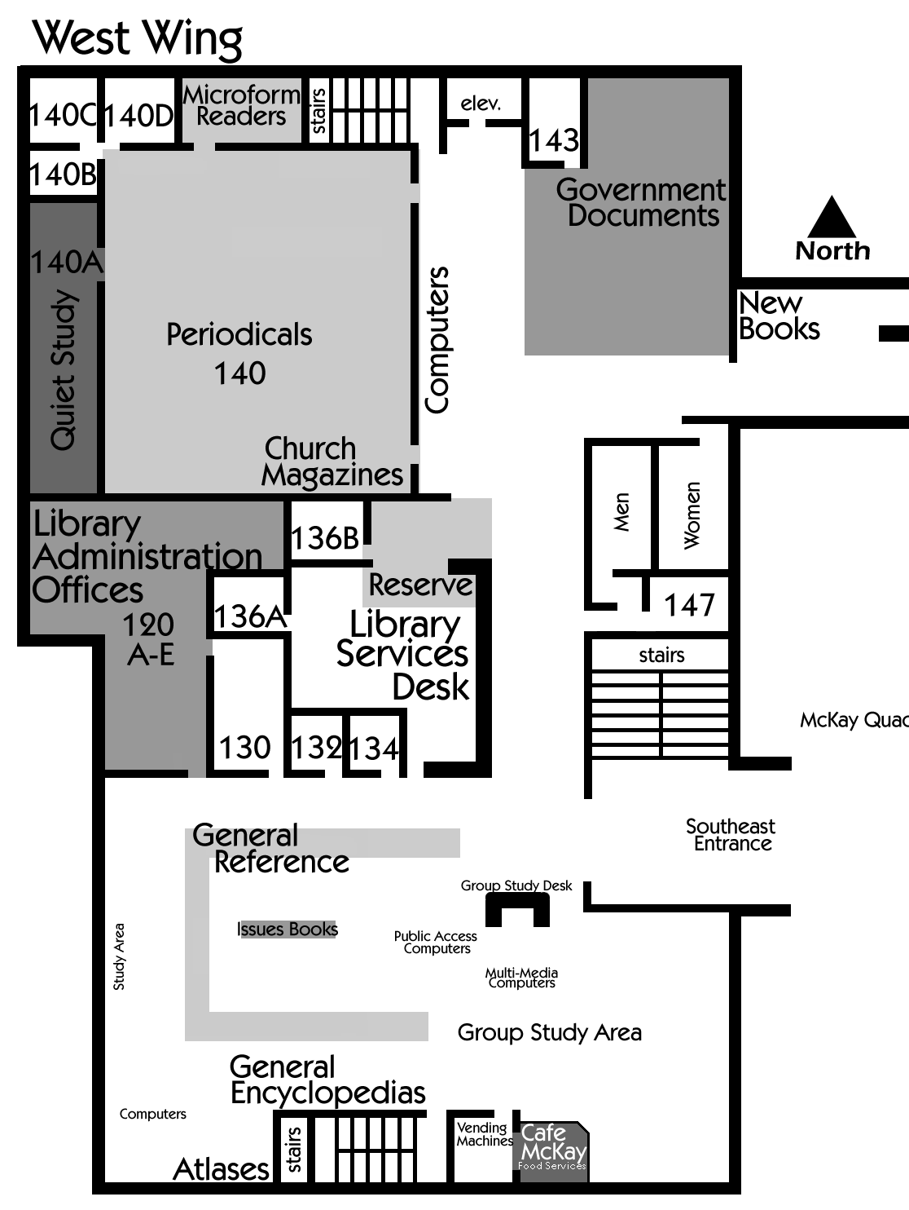

Begin the tour here at the Main Library Services Desk, where you picked up this tour guide. At first glance, you may be asking yourself, “If this is the library, where are all of the books?” Don’t worry; you will know exactly where they are by the end of the tour.
At the Library Services Desk you are able to ask questions of librarians or student workers. These workers have been well trained to help you find information, both in print and electronic format. The Music CD and Cassette collections are located behind this desk. You may obtain these items by asking a student worker to retrieve them for you.
If you need to check materials out this is the place to do it. Bring the items you need to the desk, and present your I-Card to the worker, and they will then check the materials out to you. Most books and other materials are able to be borrowed for a period of two weeks, and nearly all items can be renewed, if no one else has requested to use them.
To the south of the Library Services Desk are several computers. The bank of eight computers located just behind the study desk near the entrance are Multi-Media Computers. These Multi-Media Computers are equipped with software to help you complete assignments that require specialized programs. These computers are outfitted with programs such as Adobe Photoshop, Adobe Illustrator, Adobe Acrobat Professional and several other software titles. Each of these computers also has a scanner, and media drives available so you can work with your personal pictures.
To the west of the Multi-Media stations, you will see two more banks of computers. These are Public Access Computers. It is important to know that the Public Access Computers do not have access to word processing or other production software. These computers are designed for users who need to perform a quick search, and do not need to save their work. Among other things, these work stations link to the Library Catalog. The online library catalog replaced the old card catalog. To access the catalog, simply click on the “Internet Explorer” icon and the McKay Library home page will be displayed. If you are not in the library, this web site can be accessed at www.lib.byui.edu. When the “Library Catalog” tab is selected from the library home page and search information is entered, users will be able to find materials owned by the library. These resources include books (both print and electronic formats), magazines, journals, government documents, audio and video cassettes, audio CDs, CD-ROMs, sheet music, reserve items, and maps.
The library web-page contains more than just the library catalog. The tab labeled Site Index A to Z lists database resources where periodicals, newspapers, and government publications can be found, often in full text format. An example is GospeLink which is licensed for remote access to LDS writings by our students. We strongly recommend that you use the databases found on the library home page to help you find the academic resources you will need to successfully complete your research project.
Reference Computers have several course specific programs installed for student use. These can only be accessed while in the library. Click on “Start” to see what additional programs are available on each computer.
The Café McKay is the area near the windows by the entrance. You can purchase sandwiches and other snack food to eat. If you would like to purchase a candy bar or drink, vending machines are still available inside the glass door right next to the café. If you use these services for obtaining food, and choose to eat them in the library, please keep them in this area.
The Reference Collection is west of the Café McKay. This extremely useful section contains sources for facts and quick information about various subjects. In this area you will find specialized encyclopedias, almanacs, manuals, handbooks, and yearbooks among other items. These materials cannot be checked out. In the center of the Reference area is the Issues Collection. Books from this area may be checked out for a short time (2 days). These books include pro/con discussion of controversial topics. They help provide basic background for research.
Also in the Reference Collection are a set of big red books called the Library of Congress Subject Headings. These volumes list subject headings that are used by the Library of Congress for cataloging purposes, and can help you find the proper call number to use when looking for information on a specific topic.
On the South wall you will see several general Encyclopedia Sets. These encyclopedias such as Worldbook and Britannica will help you find background information on the topics you are researching. Dictionaries are also found against this wall.
The Atlas collection is in the Southwest corner behind the Reference Collection. This section contains general world atlases, and historical atlases for the United States and many other countries. These materials are housed on the shelves and in the wooden cabinets nearby. There are also 12 computers in this area. To use these computers you will need to log-on using your BYU-I NetID and password.
By the northwest corner of the Reference collection is a door (Room 120) that leads to the Library Administration Offices and Computer Support Areas. The next door to the east is the Digitization Center (Room 130) where documents are converted into a digital format. Please walk back to the Library Services desk.
The Reserve area is at the North end of the Library Services desk. Instructors often place materials “on reserve” so they are available to the entire class. Most of these items can be checked out for only two hours. Be aware that fines for these materials are measured by the hour rather than by the day! As you walk throughout the library, note that there are photocopiers on every floor for your convenience.
A machine that can be used to add money to your I-Card (similar to an ATM machine) is located across from the Library Services area. Visitors to campus may purchase courtesy cards using this machine. Money can also be added to I-Cards at the Library Services Desk.
Next to the Reserve area, to the North, are a number of computers. These can be used for research, word processing and e-mail. Please walk inside the glassed area to the Periodicals area. Church Magazines including the Ensign, the New Era, the Friend, and the Church News are located on the south wall inside the first door. Some foreign language editions of these magazines are also available.
The main shelves in the room contain the Magazines and Journals the library subscribes to in print format. These materials are shelved alphabetically by title. Generally, periodicals are kept for five years, but bound copies, microfilm, and microfiche copies may cover many more years. Bound copies of periodicals are shelved next to the more current copies of each title. To determine if the McKay Library subscribes to a particular periodical, check the library catalog or ask for help at the Library Services Desk.
The short shelves, near the windows, contain print copies of some Periodical Indexes. Examples include Reader’s Guide to Periodical Literature, and other indexes on various topics. Most of these indexes are subject-specific and can be used to locate articles in journals on specific topics.
A number of periodicals as well as much of our Government Document collection are available in Microfilm and Microfiche format. These publications are located in the metal cabinets lining the north and west walls of this room. Room 140E is the microfiche and microfilm reader room where you can use the readers to view and print these materials. The metal cabinets in this room contain local newspapers on microfilm.
Behind the main periodical shelves is a Quiet Study Room (Room 140A). No talking is allowed in this room. If a light bulb in one of the lamps in this room is burned out, you may obtain a new one at the Library Services Desk.
As you leave the Periodicals area, you will see shelves that hold current newspapers. The Newspapers are shelved alphabetically by title. A delay before the library receives a particular issue can be due to shipping problems and types of subscriptions. If we do not have the newspaper you would like, several hundred newspapers may be accessed online by going to databases such as NewsBank and Newspaper Source. Most online newspapers have free access only to the current issue; you must use a database to search previous issues.
None of these periodicals or newspapers can be checked out. They may, however, be taken from the room for copying. Please remember to treat these and all other library materials with care so that they are available for other people to use. Please do not write in them, mutilate them or otherwise make them unusable for the next patron. Red shelves have been marked for material return after they have been used or copyied in the library.
As you exit the glassed Periodicals area, you will see stairs and the elevator which lead to the 2nd and 3rd floors on your left. Further ahead are more shelves, which house the Government Documents. These are Federal and State documents on various subjects printed by government agencies. The subjects range from NASA to court cases to presidential papers. The McKay Library is one of 1,400 depository libraries for U.S. government documents, and receives shipments of new materials weekly. Government Documents can be searched in the library catalog, in databases, and on the open web. Many Government Documents listed in the library catalog are “electronic resources.” To view these documents, simply click on the title, scroll down, and click the hyperlink which says “CLICK HERE for online access.”
If you walk around the Government Document shelves you will see a sign pointing to the East Wing of the library. A new book display area is found in the walkway between the East and West Wing. Feel free to examine these books and check them out Before leaving the West Wing, we remind you that our “wireless hotspot” is on all floors of this wing. Other areas may not have strong signals. Please remember that cell phone use is discouraged in the library. If you must use your phone, please step out into foyers or stairwells.

East Wing– First Floor

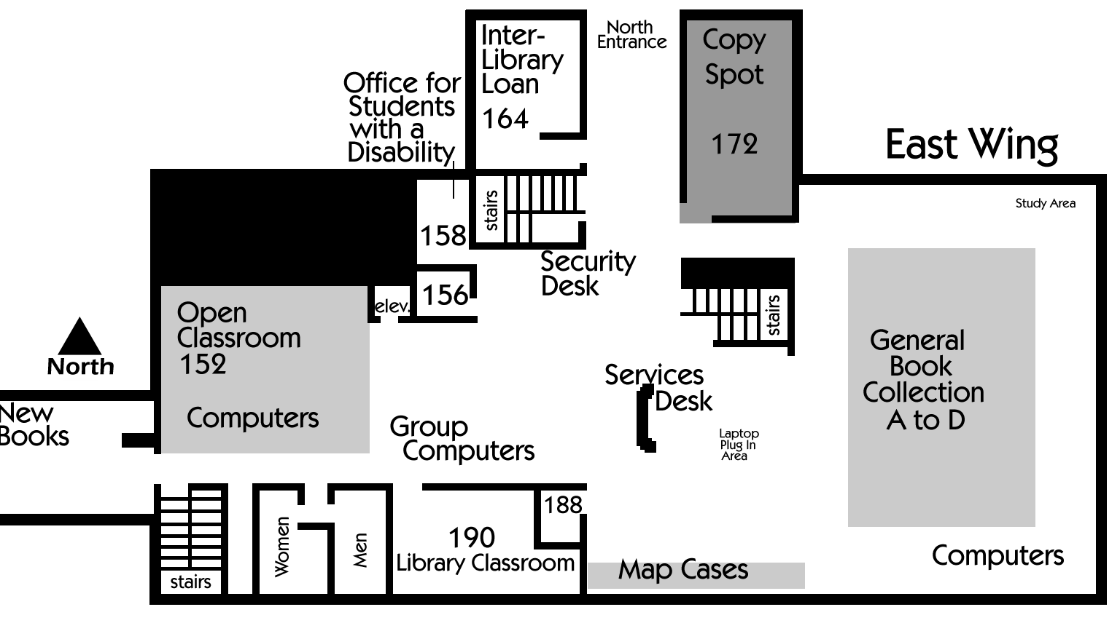

As you enter the East Wing you will see stairs leading to the 2nd Floor on your right. Just past the stairs is an Emergency Exit. This door will sound an alarm if it is opened.
On your left is an Open Classroom (McKay 152) with 48 computers. When the area is not scheduled, these computers are available for research and study.
As you walk past this classroom, note that to your left, you will see an elevator and to your right there are restrooms. Room 190 is just past the restrooms. This classroom is used to teach about library services and techniques for finding information.
Please go to the Library Services Desk ahead of you. Here you can ask research questions or check-out materials. Just behind this desk is a study area with Laptop Plug-In Access. Connection cords are available for those who need one at the main Library Services Desk.
Large flat metal Map Cases are located against the wall to your right. These cases contain topographical maps of Idaho and surrounding states, flat maps of other countries of the world, and some historical maps.
The A-D General Books Collection is housed on the rows of shelves behind the Library Services Desk. These books all have call numbers beginning with the letters A through D. The religion, philosophy, psychology, archaeology, genealogy, and world history books are located in this area. On the end row, near the computers, you will find the Oversized Books for this area. The library catalog will identify books which are located in the oversize section.
North of the Library Services Desk, is a Security Desk. Just behind this desk is a book drop box. The north entrance/exit of the library is just beyond this desk.
Just past the Security Desk, through the gates is the Interlibrary Loan Office. The Interlibrary Loan service makes the resources of libraries all over the world available to you. There is normally no charge for this service. If you need materials that are not in our library, you can request them through Interlibrary loan. A link on the library’s homepage takes you to the ILLiad software, where you can register, request materials, and view electronic copies of some items. This service may take only a couple of hours or it might take several days or weeks to retrieve materials for you, so please plan ahead. When the materials you have requested arrive, you will receive a notice to pick them up in the Interlibrary Loan office.
On the right side of Security Desk you can see the Copy Spot, which is operated by the University Press. Faculty and students can use this center for extensive or specialized copy jobs or jobs that need to be charged to a department, club, or ward. Services include color photocopies, binding, and resume printing. Domestic Faxes can also be sent and received here.
From the Security Desk, you can see two stairways leading to the 2nd Floor of the East Wing. Choose one and go up to the second floor (or use the elevator).

East Wing– Second Floor

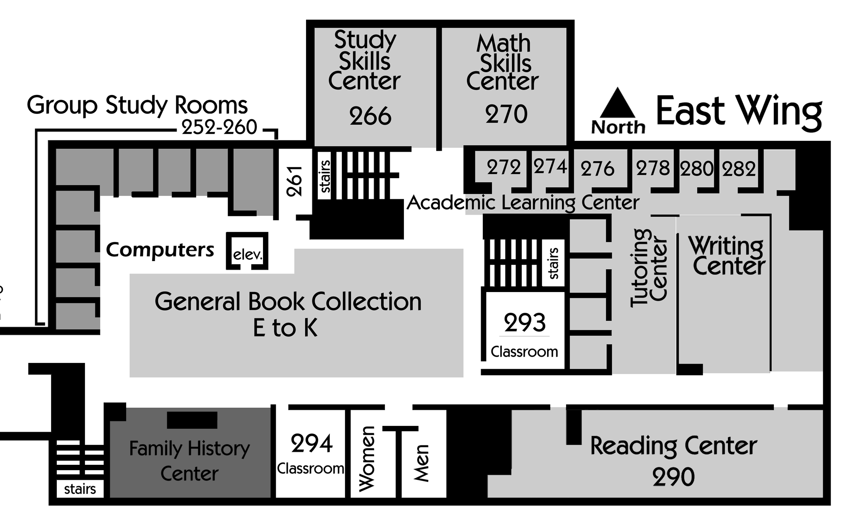

At the top of the stairs is a reception area for the Academic Learning Department. Tutoring and other services are coordinated here. If you would like to know more about the Academic Learning Department feel free to visit their website at http://www.byui.edu/AcademicLearning/.
You will notice more shelves of books located on this floor. These books contain the call number range E-K. Some of the topics covered in this area are Business, Sociology, History and Law. Begin circling these shelves on the north. You will see that Group Study Rooms can be found along the north and west walls. Group study rooms are provided for students who need to study together so that a quiet atmosphere can be maintained in the open study areas. Access to sign-up for these rooms is located on the Library’s home page. There is a two-hour time limit when using these rooms. Dry-Erase markers and erasers can be checked out at the Reserve Desk for two hours.
After passing the Group Study Rooms, you will see stairs leading to the first floor. Near the drinking fountain you will see a small open area with computers and desks. This is the Family History Resource Center. This collection contains reference books, microfilm, and census records all specifically related to genealogical research. Professional genealogical help is also available to assist you in this area. Microfilm and microfiche that are not available in our library can be ordered from the Family History Library in Salt Lake City. Now, return to the hallway leading to the West Wing.

West Wing– Second Floor
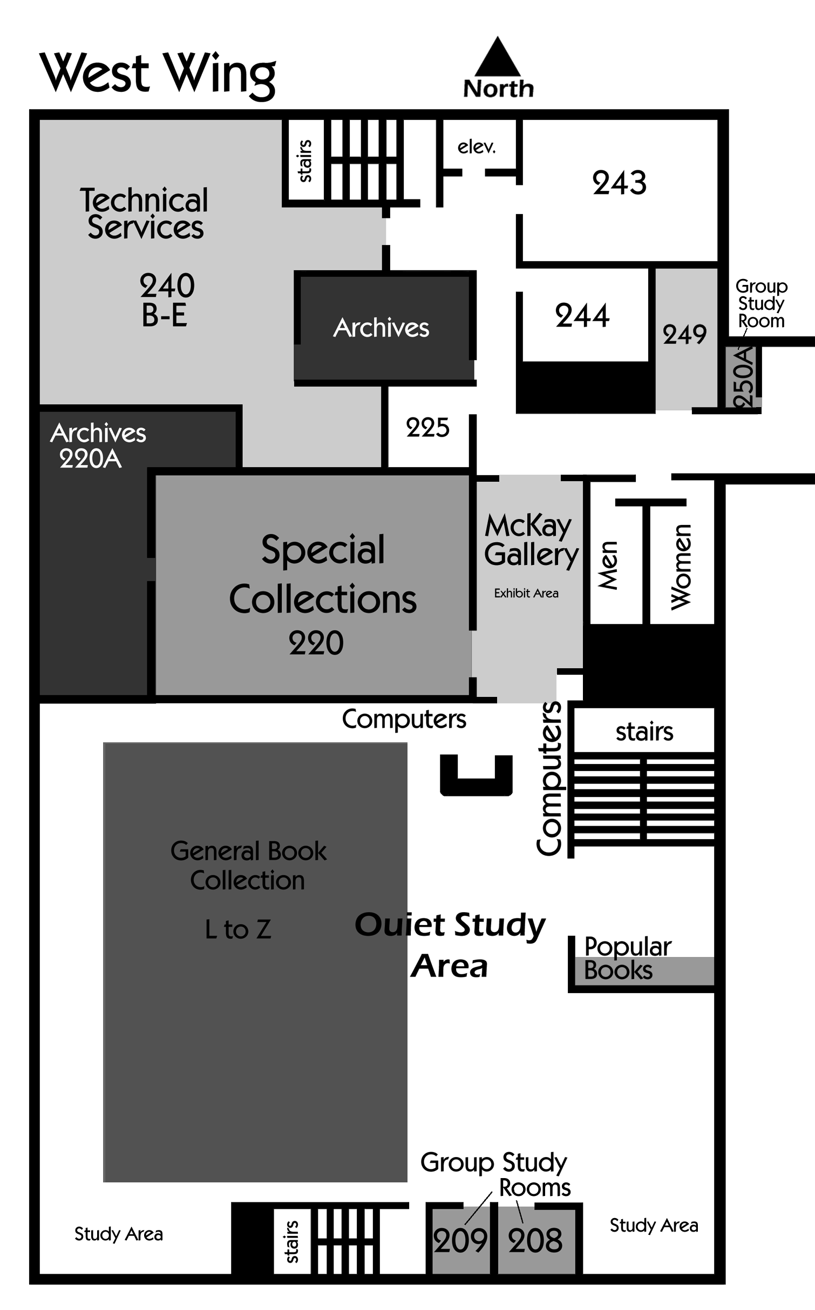
As you enter the west wing of the 2nd floor, you will first pass through a small study area. Restrooms are just past this area, to your left. Please go to the end of this hallway and turn right.
At the end of this hallway, you will see the elevator for the West Wing. By the elevator is a stairwell that you can use to go to the 1st and 3rd Floors. Near the stairs is the room 240. This is the Technical Services area of the library which includes the Acquisitions and Cataloging departments. In this area, library materials are ordered, processed, and cataloged. This area has restricted access; only employees may enter. If you wish to suggest a book be added to the library’s collection, or discuss books already owned by the library, please speak to a reference worker at the Library Services Desk. You may also drop a suggestion in the Suggestion Box located in the Reference Area on the 1st floor. Now turn and head south, back down the hallway, away from the elevator.
Room 220 is the Arthur Porter Special Collections and Archives Reading Room. In the reading room you may gain access to a variety of resources. These include historical records of BYU-Idaho, manuscripts, photographs, and rare books the library has collected. All of these items must be used only in the reading room and may not be checked out. The Special Collections and Archives have “closed stacks,” meaning only staff are allowed access to the shelves. A staff member in the reading room retrieves the materials and may monitor usage at all times. You will need to provide your driver's license or I-Card to view these rare and unique materials. The Special Collections website includes links to historic collections and photographs that have been digitized for easy access and use.
The McKay Gallery includes the display cases in the hallway. This area is used to show various art and informational exhibits throughout the school year.
Continue to walk towards the Information Desk. To the left of the Information Desk are the doors to the main stairwell. Outside these doors is the 2nd Floor landing. You will notice a portion of the Popular Book Collection. These books are for recreational reading and can be found on both the second and third floor landings. This collection is organized by the author’s last name.
Courtesy phones are located on the second and third floor landings. Also, it is appropriate to use your cell phone in these areas.
Go back inside the 2nd Floor. This area has been designed to be a quiet study area. When in this area, please respect those who are studying, by not making, or answering phone calls, talking loudly, or studying in groups.
The L-Z General Books Collection is located on this floor. Topics of these books include education, music, art, literature, science, medicine, nursing, technology, textiles, military history, and library science. Shelves for the Oversized Books in this part of the collection are in the alcove to your left.
Two Group Study Rooms are located at the south end of this wing. Like the other group study rooms, these should be reserved before use. An exit door to the south stairwell is by the group study room. Please use this stairwell to go up to the 3rd Floor West Wing. (If you take the elevator or another stairwell come to the area near this stairway once you have reached the 3rd floor.)

West Wing– Third Floor
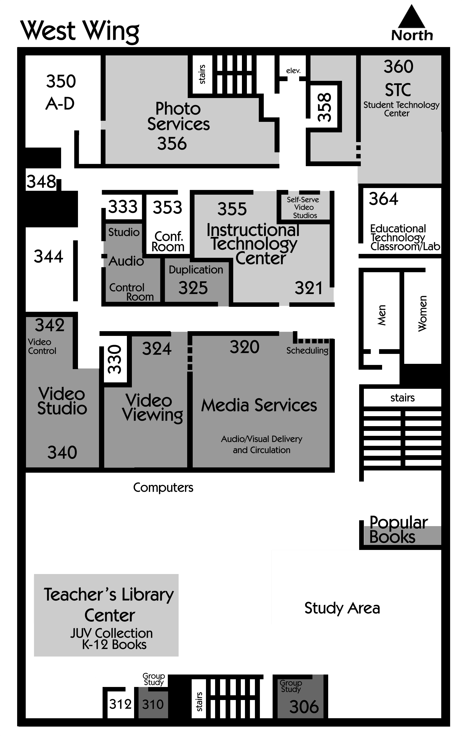

As you come onto the 3rd Floor, you see several computers and the Teacher’s Library Center (TLC). The TLC has several collections which support education students on campus. The Curriculum Collection contains textbooks adopted by the State of Idaho and other educational resources such as tapes and videos.
The Ruth H. Biddulph K-12 Collection houses the Caldecott and Newbery Medal winner books, as well as other books for children and youth. In the Library Catalog, this collection is referred to as the Juvenile Book Collection. These books may be borrowed for use outside the library at a Library Services desk.
Finally, a Children’s Paper Reader Collection is located near the Juvenile Book Collection. This paper reader collection is not listed in the library catalog. These books are organized into genres and then shelved by the author’s last name. Biography, fiction, and some foreign language books are grouped along the wall.
Generally, the TLC materials, except the juvenile book collection, are used in the building. Special permission for use outside the library is obtained from Brother Alldredge (Room 306.) After hours he may place them at the Library Services Desk for pick up.
The rest of the third floor is occupied by the Department of Academic Technology. This department is responsible for running the Student Technology Center, Video Viewing, and several other services. To learn more about these services visit the Academic Technology website at http://www.byui.edu/onlinelearning/.
Your tour is now complete. Please return this tour booklet to the Library Services desk where you picked it up. You may obtain a card for completion of this tour when you return it to the Library Services Desk. We invite you to return frequently to use the materials and services available at the David O. McKay Library.

Revised August 2008

